**Acumatica presets for using Channel Advisor configurable products integration**

1. Add new Attribute “SIZE” with any values. For example, such combo box:

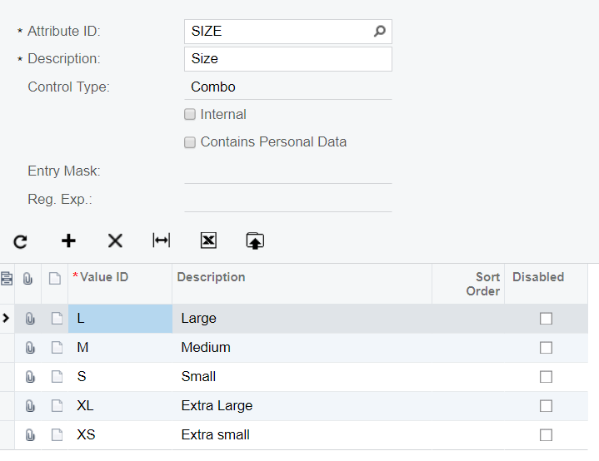

1. Add new Item Class, named “TSHIRTS”. It is important to fill all the fields which are located in the general settings area (Item Type, Valuation method etc.). The example of values you can find below:

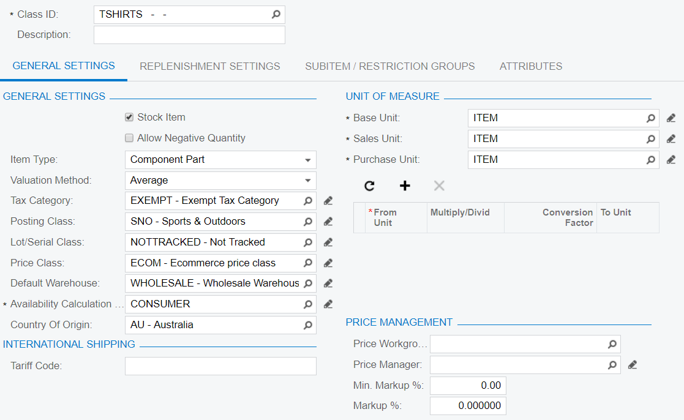

Add two attributes (not required) to this class: Color and already added Size attribute.

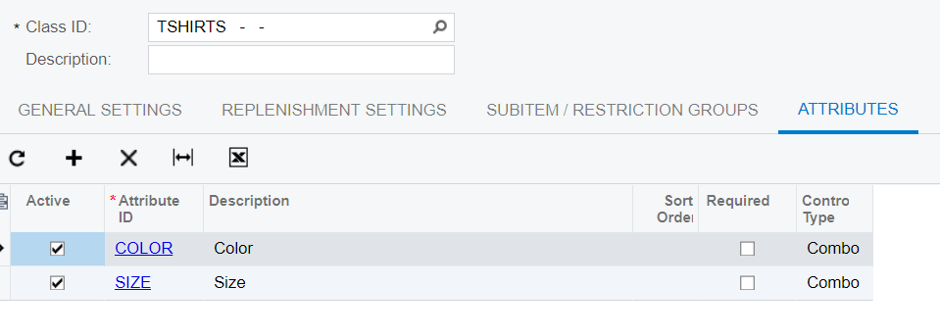

To the Channel Advisor will be exported just these configurable products and configurable child items which belong to the new “TSHIRTS” item class. If you change item class of the already exported products, they won’t be available for export/editing anymore. You can add more than two attributes to the “TSHIRTS” item class, but it is highly recommended to add “COLOR” and “SIZE” attributes also and keep them filled for all child items.

**Acumatica presets for images export**

1. Add new attributes, named “PRIMARY” and “THUMBNAIL” with text values:

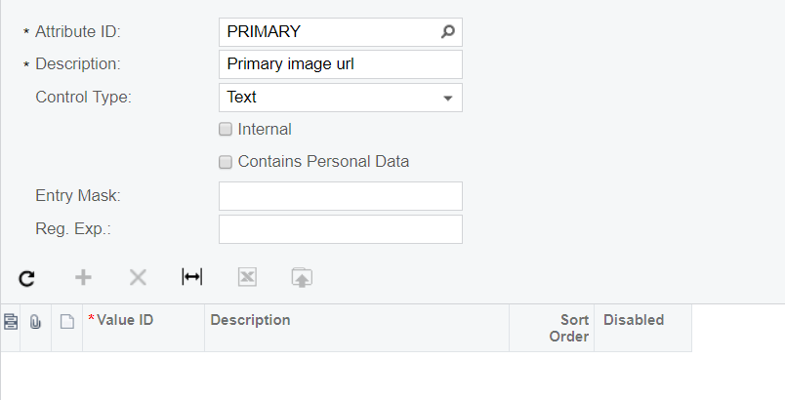

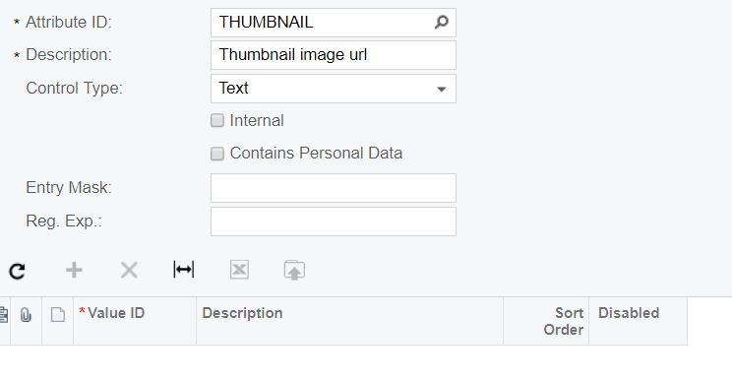

1. Choose some existed Item Class or create new one and add these two attributes to it:

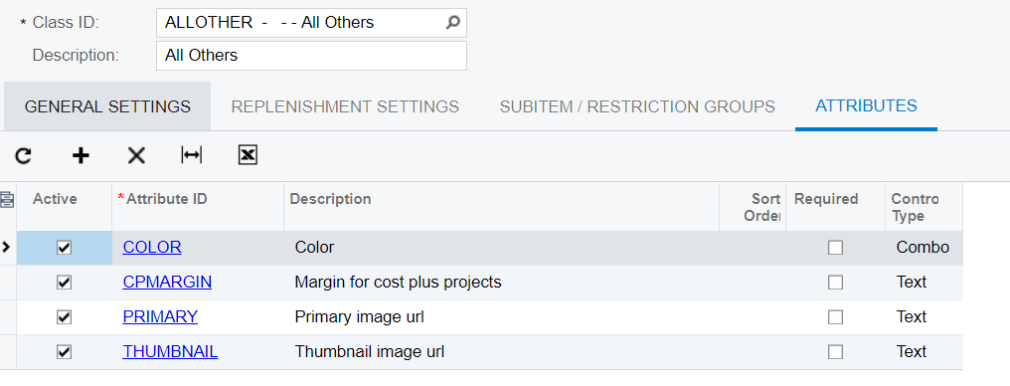

1. Create item which fits to the modified item class and put URLs of needed images to the “PRIMARY” and “THUMBNAIL” attributes or to the one of them:

